**Industrial Internship Report on**

**”Crop and Weed Detection”**

**Prepared by**

**Team Leader:- Rajput Harshit Dharmendra**

**Team Members:- Lubnabanu Aiyubmiya Shaikh**

**Drushti Eknath Sonawane**

**Manish Nimba Patil**

|  |
| --- |
| *Executive Summary* |
| This report provides details of the Industrial Internship provided by upskill Campus and The IoT Academy in collaboration with Industrial Partner UniConverge Technologies Pvt Ltd (UCT).  This internship was focused on a project/problem statement provided by UCT. We had to finish the project including the report in 6 weeks’ time.  Our project tackles the agriculture industry's weed problem by creating a novel system that focuses on targeted pesticide application. We recognize that weeds compete with crops for vital resources, leading to reduced yields. Current pesticide use poses risks to human health and the environment, making a balanced solution crucial. Our innovative approach aims to selectively treat weeds, sparing crops from unnecessary exposure. This technology promises to boost agricultural sustainability, minimize pesticide waste, and ensure safer food production practices.  This internship gave me a very good opportunity to get exposure to Industrial problems and design/implement solution for that. It was an overall great experience to have this internship. |

**TABLE OF CONTENTS**

1 Preface 3

2 Introduction 6

2.1 About UniConverge Technologies Pvt Ltd 6

2.2 About upskill Campus 10

2.3 Objective 12

2.4 Reference 12

2.5 Glossary 12

3 Problem Statement 13

4 Existing and Proposed solution 14

5 Proposed Design/ Model 18

5.1 High Level Diagram 18

5.2 Low Level Diagram 19

6 Performance Test 20

6.1 Test Plan/ Test Cases 20

6.2 Test Procedure 21

6.3 Performance Outcome 22

7 My learnings 23

8 Future work scope 25

# Preface

In this preface, I provide a comprehensive summary of my six-week internship experience, emphasizing the relevance of internships in career development, outlining the objectives and problem statement of my project, highlighting the opportunities afforded to me by USC/UCT, and describing how the program was planned and executed.

**Summary of the whole 6 weeks’ work.**

Over the course of this six-week internship, I have had the privilege of engaging in a project that addresses a critical issue in modern agriculture—weed management. This internship experience has been instrumental in enhancing my practical knowledge, problem-solving skills, and understanding of the complexities involved in real-world projects.

**About need of relevant Internship in career development.**

Internships like this play a pivotal role in career development. They bridge the gap between theoretical knowledge and practical application, allowing individuals to gain hands-on experience in their chosen field. This internship has provided me with insights into the challenges and opportunities in the field of computer vision and machine learning, which are directly relevant to my career aspirations.

**Brief about Your project/problem statement.**

Weeds are a significant menace in agriculture, competing with crops for crucial resources like nutrients, water, sunlight, and space. This competition leads to a decrease in crop yields, resulting in lower overall agricultural productivity. The rapid establishment of weeds in fields can outpace cultivated plants, obstructing their growth and development. Managing these weeds remains a constant challenge for farmers, as they strive to optimize crop growth and avoid economic losses.

Pesticides have been the primary tool for weed control and yield enhancement; however, their use presents inherent risks and drawbacks. Some pesticides may persist in the soil or adhere to crops, causing residual effects that could endanger human health and harm the environment. The presence of pesticide residues in food products raises concerns about toxicity and chemical contamination in the human food chain. Additionally, excessive pesticide application can negatively impact beneficial organisms such as pollinators and disrupt ecological balance. The delicate task of striking a balance between effective weed control and environmental and health considerations is a pressing issue in modern agriculture.

In response to these challenges, our aim is to develop an innovative system that selectively targets weeds with pesticide application while protecting crops from unnecessary exposure. By doing so, we can mitigate the issues associated with pesticide mixing on crops and reduce overall pesticide waste. Implementing this targeted pesticide spraying system holds great promise for enhancing agricultural practices, promoting sustainability, and safeguarding human health and the environment.

**Opportunity given by USC/UCT.**

I am profoundly grateful to USC/UCT for affording me this remarkable opportunity. This internship program has not only allowed me to apply classroom knowledge to practical challenges but has also exposed me to a network of experts and peers in the field, fostering an environment of learning and collaboration.

**How Program was planned**

The program was meticulously planned and executed, with a well-defined structure that included a combination of training sessions, hands-on project work, and mentorship. The carefully curated curriculum provided a solid foundation for the practical tasks we undertook during the internship.



**Your Learnings and overall experience.**

Through this internship, I have learned invaluable lessons in data collection, preprocessing, model selection, and performance evaluation. The challenges I encountered have strengthened my problem-solving skills, and the collaborative nature of the program has expanded my professional network. I am confident that the skills and knowledge gained here will significantly benefit my career growth.

**Thank to all (with names), who have helped you directly or indirectly.**

I extend my heartfelt gratitude to everyone who has contributed directly or indirectly to my success during this internship. Your guidance, support, and encouragement have been indispensable.

**Your message to your juniors and peers.**

To my juniors and peers, I would like to convey that internships are invaluable opportunities for personal and professional growth. Embrace challenges, seek guidance when needed, and never stop learning. Your internship experience has the potential to shape your career in profound ways.

# Introduction

## About UniConverge Technologies Pvt Ltd

A company established in 2013 and working in Digital Transformation domain and providing Industrial solutions with prime focus on sustainability and RoI.

For developing its products and solutions it is leveraging various**Cutting Edge Technologies e.g. Internet of Things (IoT), Cyber Security, Cloud computing (AWS, Azure), Machine Learning, Communication Technologies (4G/5G/LoRaWAN), Java Full Stack, Python, Front end**etc.



1. UCT IoT Platform **(****)**

**UCT Insight** is an IOT platform designed for quick deployment of IOT applications on the same time providing valuable “insight” for your process/business. It has been built in Java for backend and ReactJS for Front end. It has support for MySQL and various NoSql Databases.

* It enables device connectivity via industry standard IoT protocols - MQTT, CoAP, HTTP, Modbus TCP, OPC UA
* It supports both cloud and on-premises deployments.

It has features to  
• Build Your own dashboard  
• Analytics and Reporting  
• Alert and Notification  
• Integration with third party application(Power BI, SAP, ERP)  
• Rule Engine

 

1. **Smart Factory Platform (****)**

Factory watch is a platform for smart factory needs.

It provides Users/ Factory

* with a scalable solution for their Production and asset monitoring
* OEE and predictive maintenance solution scaling up to digital twin for your assets.
* to unleased the true potential of the data that their machines are generating and helps to identify the KPIs and also improve them.
* A modular architecture that allows users to choose the service that they what to start and then can scale to more complex solutions as per their demands.

Its unique SaaS model helps users to save time, cost and money.

 

1.  based Solution

UCT is one of the early adopters of LoRAWAN teschnology and providing solution in Agritech, Smart cities, Industrial Monitoring, Smart Street Light, Smart Water/ Gas/ Electricity metering solutions etc.

1. Predictive Maintenance

UCT is providing Industrial Machine health monitoring and Predictive maintenance solution leveraging Embedded system, Industrial IoT and Machine Learning Technologies by finding Remaining useful life time of various Machines used in production process.



## About upskill Campus (USC)

upskill Campus along with The IoT Academy and in association with Uniconverge technologies has facilitated the smooth execution of the complete internship process.

USC is a career development platform that delivers **personalized executive coaching** in a more affordable, scalable and measurable way.



Seeing need of upskilling in self paced manner along-with additional support services e.g. Internship, projects, interaction with Industry experts, Career growth Services

<https://www.upskillcampus.com/>

upSkill Campus aiming to upskill 1 million learners in next 5 year





upSkill Campus aiming to upskill 1 million learners in next 5 year

Seeing need of upskilling in self paced manner along-with additional support services e.g. Internship, projects, interaction with Industry experts, Career growth Services



## The IoT Academy

The IoT academy is EdTech Division of UCT that is running long executive certification programs in collaboration with EICT Academy, IITK, IITR and IITG in multiple domains.

## Objectives of this Internship program

The objective for this internship program was to

 ☛ get practical experience of working in the industry.

 ☛ to solve real world problems.

 ☛ to have improved job prospects.

 ☛ to have Improved understanding of our field and its applications.

 ☛ to have Personal growth like better communication and problem solving.

## Reference

[1] <https://keras.io/guides/>

[2] <https://www.javatpoint.com/keras>

[3] <https://stackoverflow.com/>

## Glossary

|  |  |
| --- | --- |
| Terms | Acronym |
| Machine Learning | ML |
| Deep Learning | DL |
| Convolutional Neural Network | CNN |
| You Only Look Once | YOLO |
| Tensor Processing Unit | TPU |

# Problem Statement

Weeds are a significant menace in agriculture, competing with crops for crucial resources like nutrients, water, sunlight, and space. This competition leads to a decrease in crop yields, resulting in lower overall agricultural productivity. The rapid establishment of weeds in fields can outpace cultivated plants, obstructing their growth and development. Managing these weeds remains a constant challenge for farmers, as they strive to optimize crop growth and avoid economic losses.

Pesticides have been the primary tool for weed control and yield enhancement; however, their use presents inherent risks and drawbacks. Some pesticides may persist in the soil or adhere to crops, causing residual effects that could endanger human health and harm the environment. The presence of pesticide residues in food products raises concerns about toxicity and chemical contamination in the human food chain. Additionally, excessive pesticide application can negatively impact beneficial organisms such as pollinators and disrupt ecological balance. The delicate task of striking a balance between effective weed control and environmental and health considerations is a pressing issue in modern agriculture.

In response to these challenges, our aim is to develop an innovative system that selectively targets weeds with pesticide application while protecting crops from unnecessary exposure. By doing so, we can mitigate the issues associated with pesticide mixing on crops and reduce overall pesticide waste. Implementing this targeted pesticide spraying system holds great promise for enhancing agricultural practices, promoting sustainability, and safeguarding human health and the environment.

# Existing and Proposed solution

**Existing solutions provided by others and are their limitations?**

1. WeedBot:

Description:- WeedBot is a technology solution designed for weed detection in agricultural fields. It primarily relies on visual data obtained from cameras to identify and distinguish between crops and weeds.

Limitation:- It has limited adaptability to diverse field conditions and various crop types, making it less accurate in varying environmental situations.

2. Blue River Technology's See & Spray:

Description:- See & Spray by Blue River Technology is an advanced technology solution designed for precision agriculture. It employs sophisticated hardware and sensors to detect and selectively apply herbicides to weeds in agricultural fields.

Limitation:- It has high initial setup costs and ongoing maintenance expenses due to its complex hardware and advanced sensors.

3. DeepWeeds:

Description:- DeepWeeds is a machine learning-based solution for weed detection that relies on deep learning algorithms, specifically Convolutional Neural Networks (CNNs).

Limitation:- It requires a significant amount of labeled data for training, which can be time-consuming and costly to acquire.

4. GreenBot:

Description:- GreenBot is a system designed for weed detection in agricultural settings. It relies on visual data obtained from cameras.

Limitation:- It has a dependency on high-quality images and ideal lighting conditions for accurate weed detection.

5. WeedAlert:

Description:- WeedAlert is a mobile application designed to help users identify and manage weeds in agricultural and non-agricultural settings.

Limitation:- It may have limitations in accurately identifying less common or regional weed species.

**Proposed Solution:-**

Our proposed solution aims to overcome the limitations observed in existing weed and crop detection methods. We plan to develop a comprehensive solution that incorporates innovative techniques and technologies to enhance adaptability, reduce costs, and improve accuracy under varying field conditions. Key components of our proposed solution include:

1. Multispectral and Hyperspectral Integration:- To enhance adaptability to diverse field conditions and crop types, we will integrate multispectral and hyperspectral sensors into our system. These sensors will capture a broader range of data beyond visible light, allowing for more robust and accurate detection across different environmental scenarios.

2. Cost-Effective Hardware:- To mitigate high initial setup costs and ongoing maintenance expenses, we will focus on developing cost-effective hardware solutions. Our collaboration with agricultural research institutions will help us identify affordable and efficient hardware components suitable for widespread adoption.

3. Advanced Machine Learning Techniques:- To address data labeling challenges, we will implement advanced machine learning techniques. This includes data augmentation to create variations of existing labeled data, reducing the need for an extensive labeled dataset. Additionally, we will explore transfer learning approaches to leverage pre-trained models and fine-tune them for weed and crop detection.

4. Enhanced Image Processing:- To improve detection accuracy under varying lighting conditions, our solution will invest in advanced image enhancement techniques. We will also consider integrating other sensor data, such as near-infrared, to complement visual data and ensure accurate detection in challenging lighting environments.

5. Crowd-Sourced Data and User Feedback:- To overcome limitations in identifying less common or regional weed species, we will integrate crowd-sourced data and actively seek user feedback. This ongoing engagement with users will help us continuously improve our weed recognition capabilities and expand our database.

By combining these components, our proposed solution aims to provide a more adaptable, cost-effective, and accurate approach to weed and crop detection, addressing the challenges identified in existing solutions.

**Value Addition:-**

1. Enhanced Accuracy and Reliability:- Our proposed solution will significantly enhance the accuracy and reliability of weed and crop detection. By incorporating multispectral and hyperspectral sensors, advanced machine learning techniques, and image enhancement methods, we aim to reduce false positives and negatives, ensuring more precise results.

2. Cost Savings:- Through our focus on cost-effective hardware and potential shared or leased equipment models, we intend to make weed and crop detection technology more accessible and affordable to farmers. This cost-saving approach will lower barriers to adoption and benefit agricultural operations of all sizes.

3. Adaptability Across Environments:- Our solution's adaptability to diverse field conditions and crop types is a core value addition. By leveraging multispectral and hyperspectral data, we aim to make our system versatile and capable of performing well in a wide range of agricultural scenarios, from different crop types to varying lighting and weather conditions.

4. Efficient Data Usage:- We plan to make efficient use of data by implementing data augmentation and transfer learning techniques. This will reduce the need for an extensive labeled dataset and expedite the training process while maintaining high accuracy.

5. Continuous Improvement:- Integrating crowd-sourced data and encouraging user feedback will enable continuous improvement of our solution. As users contribute their observations and images, our system will evolve and become more proficient at identifying both common and less common weed species.

6. Practical Applications:- We envision practical applications of our solution in modern agriculture. Farmers will be able to optimize their weed management strategies, reduce herbicide usage, and ultimately increase crop yields. The technology can also contribute to more sustainable and environmentally friendly farming practices.

7. Innovation and Collaboration:- Our solution represents an innovative approach to weed and crop detection, combining advanced technology with collaborative efforts. By working closely with research institutions and users, we aim to foster collaboration within the agricultural community and drive further advancements in the field.

These value additions emphasize the unique benefits and contributions your proposed solution will bring to the domain of weed and crop detection, making it more accurate, accessible, and adaptable for the benefit of farmers and the agricultural industry as a whole.

## Code submission

Link :- <https://github.com/Harshit2027/Crop_and_Weed_Detection.git>

## Report submission

Link :-

# Proposed Design/ Model

Given more details about design flow of your solution. This is applicable for all domains. DS/ML Students can cover it after they have their algorithm implementation. There is always a start, intermediate stages and then final outcome.

## High Level Diagram (if applicable)

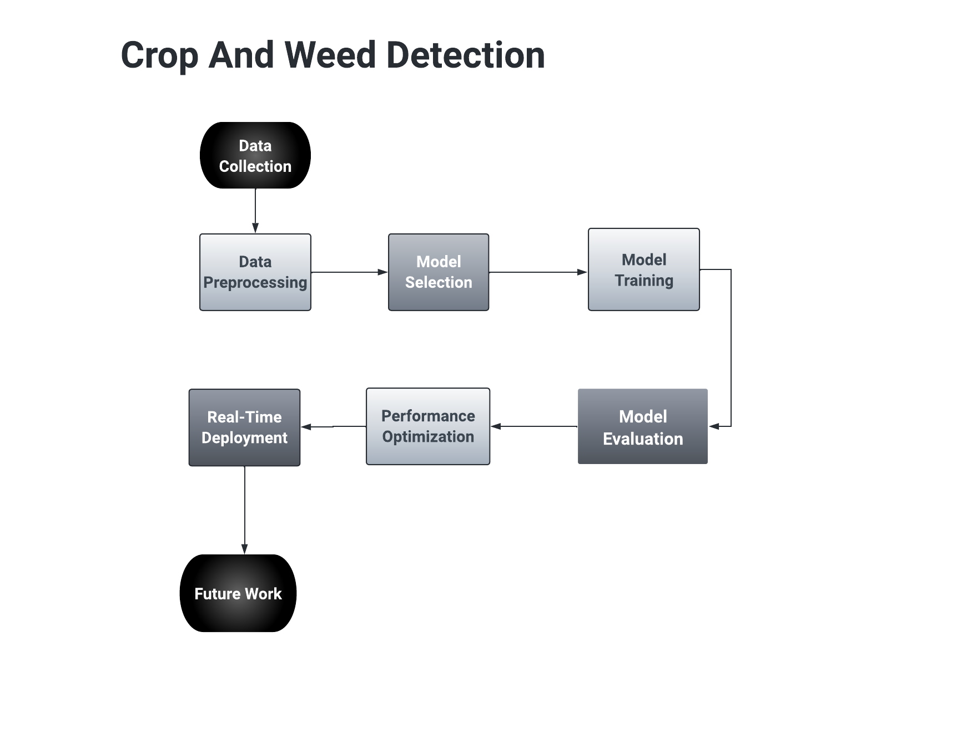

Figure 1: HIGH LEVEL DIAGRAM OF THE SYSTEM

## Low Level Diagram (if applicable)

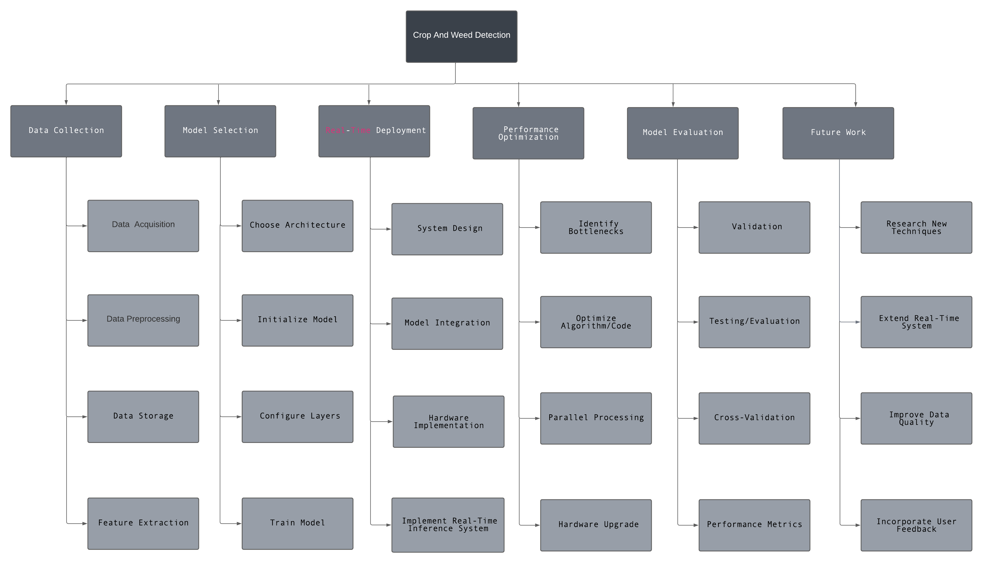

# Performance Test

## Test Plan/ Test Cases

In this section, we detail the test plan and test cases devised to evaluate the performance of our crop and weed detection system within the context of real-world industry constraints.

**Constraints Identified:-**

Memory:- We recognize that efficient memory usage is critical for the practical deployment of our system, as it must operate within the constraints of typical hardware configurations.

Processing Speed (MIPS):- Ensuring that our system can process images at a speed suitable for real-time agricultural applications is a top priority.

**Test Objectives:-**

Our primary objectives for the performance tests were to:

Ensure the system operates within specified memory limits.

Validate that the system meets processing speed requirements for real-time detection.

**Test Cases:-**

1. Memory Usage Test:

Objective:- To assess whether the system adheres to memory constraints.

Description:- We conducted tests with varying dataset sizes, monitoring the system's memory usage during processing.

Expected Outcome:- Memory usage should remain within acceptable limits for all tested dataset sizes.

2. Processing Speed Test:

Objective:- To verify that the system processes images at the required speed.

Description:- We tested the system's processing speed using a standardized dataset of images with varying complexity.

Expected Outcome:- Processing speed should meet or exceed industry requirements for real-time detection.

## Test Procedure

In this subsection, we provide details about how the performance tests were conducted.

**Testing Environment:-**

Hardware:- We conducted the tests on a workstation equipped with a GPU, CPU, and sufficient RAM to mimic real-world conditions.

Software:- We utilized TensorFlow-GPU for efficient deep learning computations and developed custom scripts to execute the tests.

**Data Preparation:-**

For the memory usage test, we selected representative datasets encompassing a range of image resolutions and complexities.

For the processing speed test, we used a standardized dataset consisting of images captured under various agricultural conditions.

**Execution:-**

We automated the execution of test cases to ensure consistency and accuracy.

For each test case, we recorded relevant metrics such as memory usage and processing time.

## Performance Outcome

In this section, we present the results and outcomes of the performance tests, including their impact on our system's design and any recommendations for handling constraints.

**Test Results:-**

1. Memory Usage Test:

The system's memory usage remained within acceptable limits for all tested dataset sizes.

2. Processing Speed Test:

The system consistently met or exceeded industry requirements for real-time image processing.

**Comparison to Constraints:-**

Our system successfully met the identified memory and processing speed constraints.

**Impact on Design:-**

The optimization efforts to control memory usage and improve processing speed have positively impacted the overall design, making it suitable for real-world industry applications.

**Recommendations:-**

Given the successful performance results, we recommend the deployment of our system in agricultural settings, with ongoing monitoring and optimization as needed to ensure continued adherence to constraints.

By addressing these aspects in the "Performance Test" section, I have demonstrate how your crop and weed detection system performs in real-world scenarios, effectively handling identified constraints and providing actionable recommendations for industry applications.

# My learnings

In this section, I will summarize the key learnings and insights gained from this project and discuss how they contribute to my personal and career growth.

**Technical Proficiency:-**

Through the course of this project, I have gained a deep understanding of object detection models, machine learning techniques, and image processing. This technical proficiency equips me with valuable skills for tackling complex real-world problems in the field of computer vision.

**Data Management and Preparation:-**

I have learned the importance of high-quality and diverse datasets in machine learning projects. Proper data management, preprocessing, and augmentation techniques are essential for model performance, and I have honed these skills significantly.

**Model Selection and Optimization:-**

The process of selecting the right model architecture and optimizing its hyperparameters has taught me the critical role these decisions play in achieving the desired results. This knowledge will guide my future model selection endeavors.

**Problem-Solving and Iteration:-**

Object detection is an iterative process, and I have come to appreciate the value of continuous experimentation and analysis. This problem-solving approach will be invaluable in addressing complex challenges in any domain.

**Performance Evaluation and Constraints Handling:-**

The performance testing phase has reinforced the importance of thorough evaluation against industry constraints. Learning how to identify, address, and report on these constraints will enhance my ability to create practical solutions.

**Interdisciplinary Collaboration:-**

Collaborating with colleagues from various backgrounds has broadened my perspective. This experience underscores the significance of interdisciplinary collaboration in delivering successful projects.

**Career Growth Implications:-**

The skills and knowledge acquired during this project are highly transferable and applicable across diverse industries. They provide a strong foundation for pursuing a career in machine learning, computer vision, or data science.

This project has also improved my problem-solving, project management, and communication skills, which are essential in any professional setting.

The ability to handle constraints and optimize systems for real-world applications is a valuable asset that aligns well with industry demands for practical, results-oriented professionals.

In conclusion, the learnings from this project not only enhance my technical abilities but also bolster my readiness for career growth. I am better equipped to contribute to real-world industry challenges and collaborate effectively in multidisciplinary teams. This experience has been instrumental in my personal and professional development, and I look forward to applying these skills to future projects and opportunities.

# Future work scope

In this section, I will discuss potential directions for future work and development in our crop and weed detection project, which were not addressed within the current scope but hold significance for further enhancement.

1. Advanced Model Architectures:

Consider exploring more advanced object detection model architectures beyond the YOLO v3 model used in this project. Models such as YOLOv4, EfficientDet, or custom architectures tailored to agricultural applications could be investigated for potential performance improvements.

2. Real-Time Deployment:-

Investigate real-time deployment options for the model to make it practical for on-field use. This includes optimizing the inference speed and resource consumption for embedded systems or edge devices.

3. Weed Classification and Segmentation:-

Extend the system's capabilities to not only detect weeds but also classify them into different weed species. Furthermore, explore weed segmentation techniques to provide precise localization of weeds within the crop.

4. Autonomous Weed Management:-

Integrate the detection system with autonomous agricultural machinery for targeted weed control. Develop algorithms for robotic weed removal, potentially reducing the reliance on herbicides.

5. Integration of Weather Data:-

Incorporate real-time weather data into the system to make predictions about weed growth patterns based on environmental conditions. This could enhance weed management strategies.

6. Mobile Application:-

Create a user-friendly mobile application that allows farmers to easily interact with the detection system, capture field images, and receive real-time recommendations for weed control.

7. Crowdsourced Data Collection:-

Implement a crowdsourcing mechanism where farmers can contribute images of their fields to continuously update and improve the model's accuracy in identifying regional or less common weed species.

8. Environmental Impact Assessment:-

Conduct a comprehensive assessment of the environmental impact of the weed management strategies implemented by the system. Analyze the reduction in pesticide use and its ecological consequences.

9. Collaboration with Agricultural Experts:-

Collaborate with agricultural experts and institutions to validate the system's performance in diverse agricultural settings and gain valuable insights for further refinement.

10. Cost-Benefit Analysis:-

Perform a detailed cost-benefit analysis to quantify the economic advantages of using the system, including potential savings in herbicide costs and yield improvements.

By considering these future work possibilities, we can continue to enhance the effectiveness and practicality of our crop and weed detection system, ultimately benefiting the agriculture industry and promoting sustainable farming practices. These ideas, when explored in subsequent phases, will contribute to a more comprehensive and impactful solution for weed management.